Graph Exercises!

Answer the questions for a washing machine ‘state machine’ diagram

1. Excluding the ‘black dot’, how many nodes are there? 6
2. How many edges are there? 9
3. Is the graph a multigraph? Yes
4. Is this a directed or undirected graph? Undirected
5. Is the graph cyclic or acyclic? Cyclic

**Answer the questions on Singapore’s MRT/LRT systems**

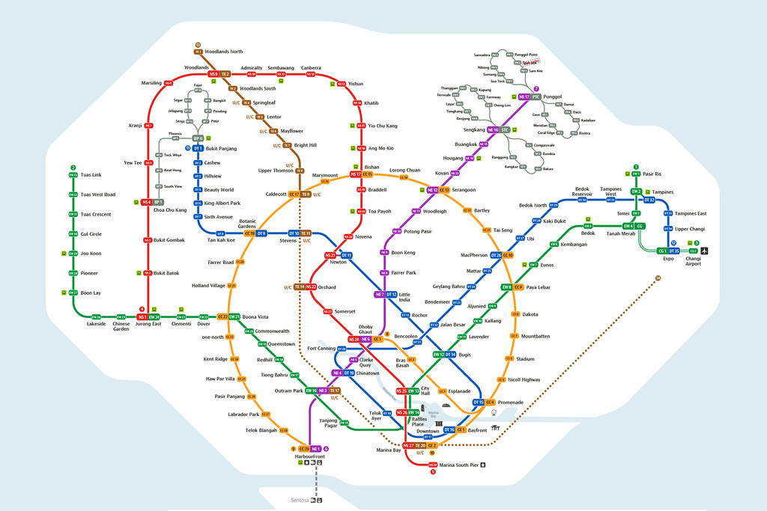

1. Discuss if the following lines are cyclic or acyclic? Is it Multigraph?
   1. Downtown Line (Blue), Acyclic, not multigraph
   2. Circle Line (Orange), Acyclic, not multigraph
   3. North-South (Red) and East-West (Red, Green) lines, Cyclic, multigraph
   4. North-East (Purple) and Downtown (Blue) lines, Cyclic, multigraph
   5. Downtown (Blue) and East-West (Green) lines, Cyclic, multigraph
   6. Circle (Orange) and North-East (Purple) lines, Cyclic, multigraph
   7. Downtown (Blue) and North-South (Red) lines, Acyclic, not multigraph
2. What is the degree for the following MRT stations:
   1. Tanah Merah, 3
   2. Sengkang, 4
   3. Botanic Gardens, 4
   4. Dhoby Ghaut, 5
3. Create the adjacency matrix for the MRT stations in the table.

You only need to fill up half the table as it is symmetric about the diagonal.

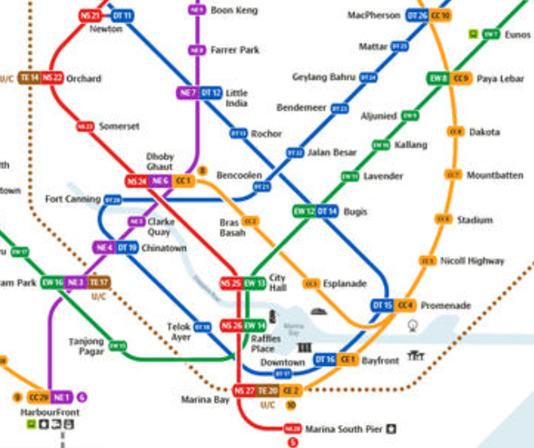

|  |  |  |  |  |  |  |  |  |  |  |  |  |
| --- | --- | --- | --- | --- | --- | --- | --- | --- | --- | --- | --- | --- |
|  | Orchard | Somerset | Dhoby Ghaut | City Hall | Bras Basah | Raffles Place | Marina Bay | Bugis | Tanjong Pagar | Outram | Chinatown | Clarke Quay |
| Orchard | 1 | 1 | 0 | 0 | 0 | 0 | 0 | 0 | 0 | 0 | 0 | 0 |
| Somerset | 1 | 1 | 1 | 0 | 0 | 0 | 0 | 0 | 0 | 0 | 0 | 0 |
| Dhoby Ghaut | 0 | 1 | 1 | 1 | 1 | 0 | 0 | 0 | 0 | 0 | 0 | 1 |
| City Hall | 0 | 0 | 1 | 1 | 0 | 1 | 0 | 1 | 0 | 0 | 0 | 0 |
| Bras Basah | 0 | 0 | 1 | 0 | 1 | 0 | 0 | 0 | 0 | 0 | 0 | 0 |
| Raffles Place | 0 | 0 | 0 | 1 | 0 | 1 | 1 | 0 | 1 | 0 | 0 | 0 |
| Marina Bay | 0 | 0 | 0 | 0 | 0 | 1 | 1 | 0 | 0 | 0 | 0 | 0 |
| Bugis | 0 | 0 | 0 | 1 | 0 | 0 | 0 | 1 | 0 | 0 | 0 | 0 |
| Tanjong Pagar | 0 | 0 | 0 | 0 | 0 | 1 | 0 | 0 | 1 | 1 | 0 | 0 |
| Outram | 0 | 0 | 0 | 0 | 0 | 0 | 0 | 0 | 1 | 1 | 1 | 0 |
| Chinatown | 0 | 0 | 0 | 0 | 0 | 0 | 0 | 0 | 0 | 1 | 1 | 1 |
| Clarke Quay | 0 | 0 | 1 | 0 | 0 | 0 | 0 | 0 | 0 | 0 | 1 | 1 |